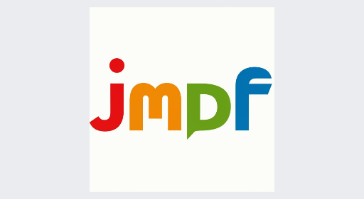

**Journal of Medical and Dental Frontiers**

I/we hereby confirm our active involvement in the intellectual contributions, conception, design, data analysis, interpretation, and manuscript writing. We willingly take public responsibility for this work and agree to be acknowledged as contributors. The manuscript, in our belief, reflects sound and valid work. Each author affirms adherence to the authorship criteria established by the ICMJE.

This manuscript, authored by us, has not been published elsewhere, nor is it under consideration for publication elsewhere, except as outlined in the accompanying cover letter. We assert that all study data are presented herein, with no separate or pending publications of the data.

In the event that editors request, we commit to providing data or information and will fully cooperate in obtaining and furnishing the necessary details upon their request. Any financial interests, direct or indirect, pertaining to individual contributors and associated with the manuscript's content have been disclosed in the cover letter. The cover letter also outlines external sources of project support.

I/we hereby transfer, assign, or convey all copyright ownership, along with any incidental rights, exclusively to the Journal should it choose to publish this work. The Journal will possess rights including copyright, permission to republish the article wholly or partially, with or without fee, the ability to produce preprints or reprints, and the right to translate into languages other than English for sale or free distribution. Additionally, the Journal has the right to republish the work in any mechanical or electronic format as part of a collection of articles.

To facilitate the editorial process, we authorize the corresponding author to implement necessary changes as per the Journal's requests, undertake corresponding responsibilities on our behalf, and act as the manuscript's guarantor. The article will be published under the terms of national and international copyright grants, providing users with an irrevocable worldwide, perpetual right of access. Users are licensed to copy, distribute, perform, and publicly display the work, as well as create and distribute derivative works in any digital medium for reasonable non-commercial purposes, under the latest Creative Commons Attribution-NonCommercial 4.0 International (CC BY-NC 4.0) license.

**Conflict of interest:**

**Funding details:**

|  |  |  |  |
| --- | --- | --- | --- |
| **Article ID** |  | **Date** |  |
| **Title:** |  | | |
| **Author Sequence** | **Author name**  **(First, Middle, Last)** | **Affiliation** | **Signature** |
| **1** |  |  |  |
| **2** |  |  |  |
| **3** |  |  |  |
| **4** |  |  |  |
| **5** |  |  |  |

**Corresponding author details:**

**Email of corresponding author:**

**Mobile no:**

**Please send filled and scanned copy to** [**jmdfjournal@gmail.com**](mailto:jmdfjournal@gmail.com)**.**